**Mini Project 2 (Stop-Watch)**

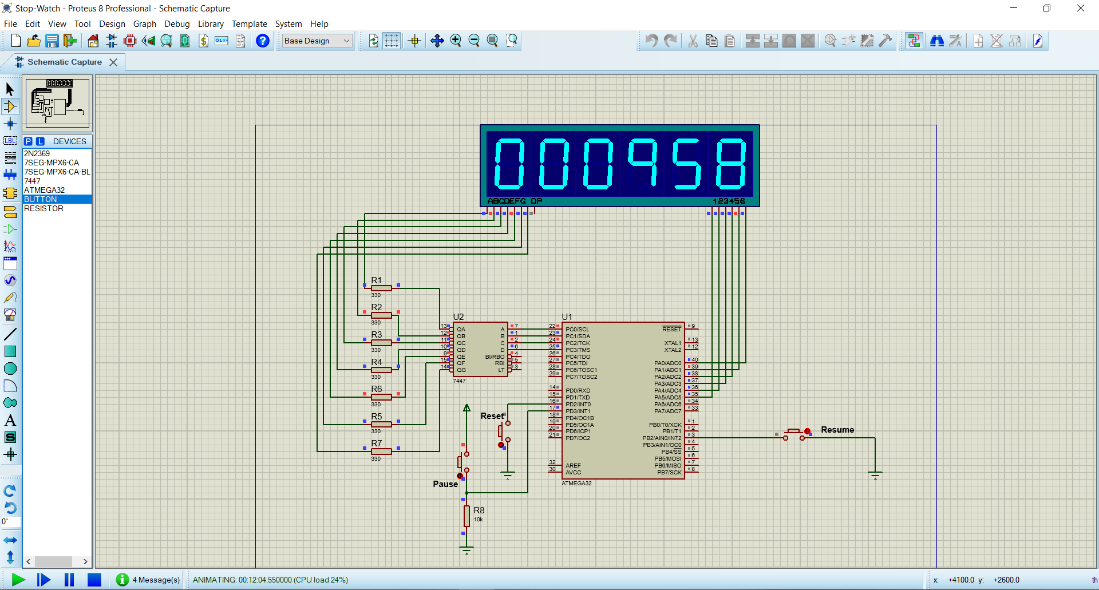

MT Embedded Diploma 71

Date: 15/9/2022

Author: Erini G

Project Requirements

Implement the following Stop Watch system with the specifications listed below:

1. Use ATmega32 Microcontroller with frequency 1Mhz.
2. Configure Timer1 in ATmega16 with CTC mode to count the Stop Watch time.
3. Use six Common Anode 7-segments.
4. Connect the six 7-segments in the project using the multiplexed technique. You should use one 7447 decoder for all 7-segments and control the enable/disable for each 7-segement using a NPN BJT transistor connect to one of the MCU pins.
5. We can connect more than one 7-segment display by using the Multiplexing method.In this method, at a time one 7-segment display is driven by the Microcontroller and the rest are OFF. It keeps switching the displays using transistors. Due to the persistence of vision, it appears as a normal display.
6. Connect 7447 decoder 4-pins to the first 4-pins in PORTC.
7. Use first 6-pins in PORTA as the enable/disable pins for the six 7-segments.
8. Stop Watch counting should start once the power is connected to the MCU.
9. Configure External Interrupt INT0 with falling edge. Connect a push button with the internal pull-up resistor. If a falling edge detected the Stop Watch time should bereset.
10. Configure External Interrupt INT1 with raising edge. Connect a push button with the external pull-down resistor. If a raising edge detected the Stop Watch time should bepaused.
11. Configure External Interrupt INT2 with falling edge. Connect a push button with the internal pull-up resistor. If a falling edge detected the Stop Watch time should beresumed.
12. Check this video: <https://youtu.be/emp-musYxII>

Proteus Notes:

Once the simulation starts the timer starts counting as well.

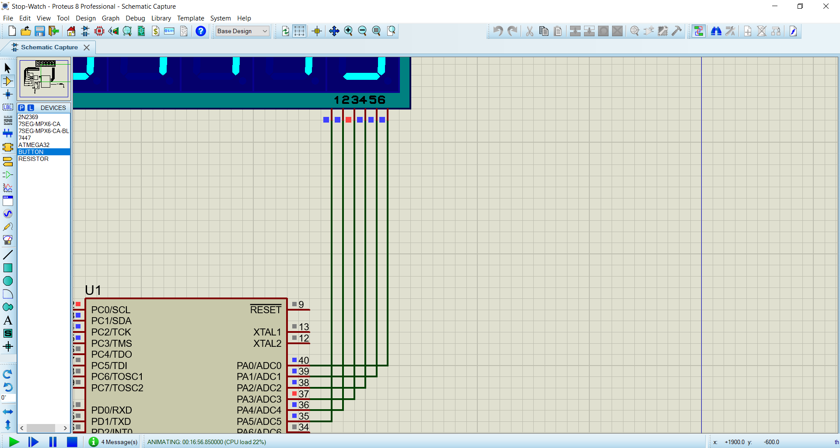The 7-Segment enable pins are connected with the port as in the below image, so the displaying starts from left to right.

Code Notes:

The time is stored as array members (seconds, minutes, hours).

Macros was used to avoid using magic numbers as much as possible.

Timer1 ISR only sets the global variable g_TimerFlag, so it would be short and deterministic.

Prescaler choice was 1024 to lower the compare match value as much as possible.

Delay is 10 microsec so the user wouldn’t notice the the any of the 7-segments is off.